- We usually give cog-wheel for aggregators. Can we have that instead of check-marks? Done
- Is the user name (vertically) centrally aligned with refresh/logout? Done
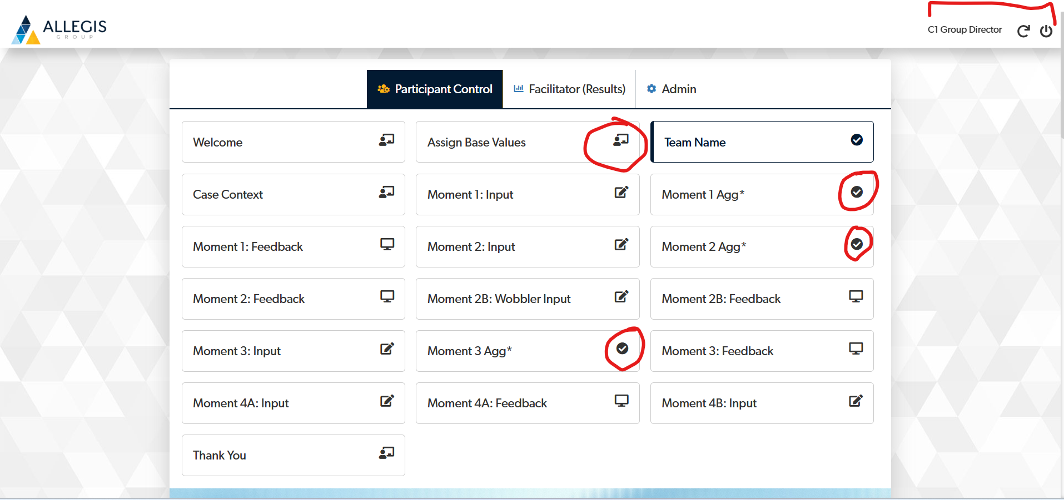

Add an icon for Data export. Done
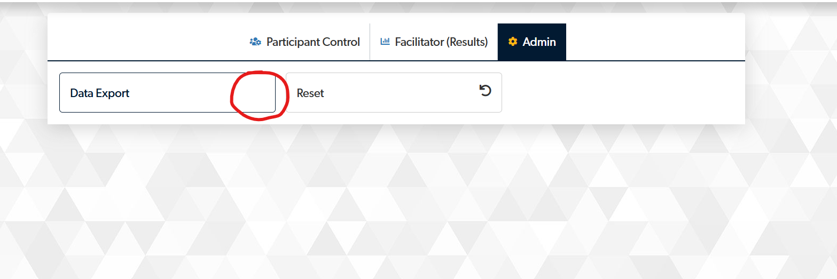

When I log into as user, first an abstract background image loads and then it turns to blank screen.
It should either stay as a screen with abstract image or should load as a blank screen.
I prefer the screen with abstract image.
This issue is not reflecting on my end

Leader login.


Follower login This issue is not reflecting on my end
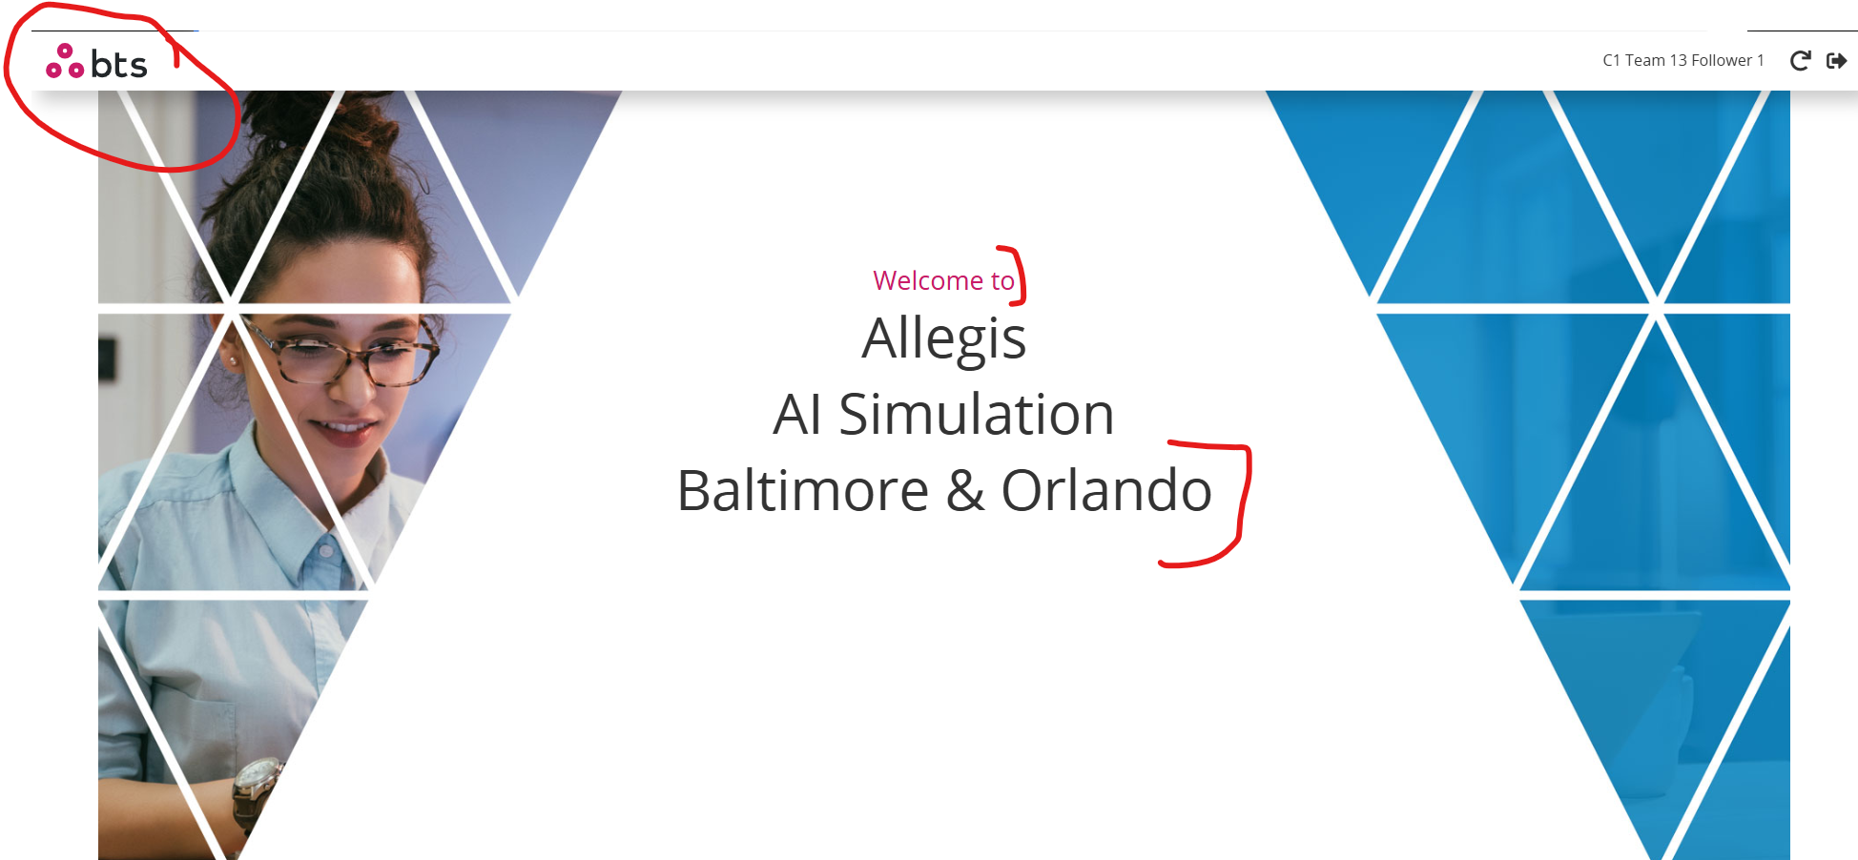

I think we should keep it centrally aligned. Done- I have aligned it to top left

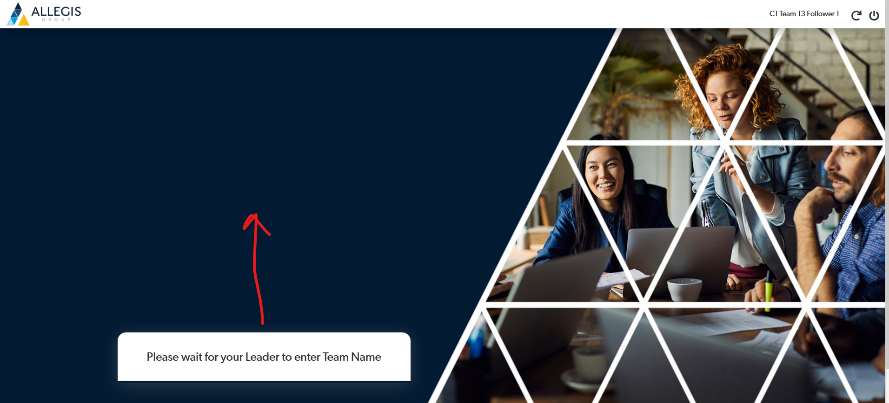

This header loads as a normal font and then picks up the bold font.WIP

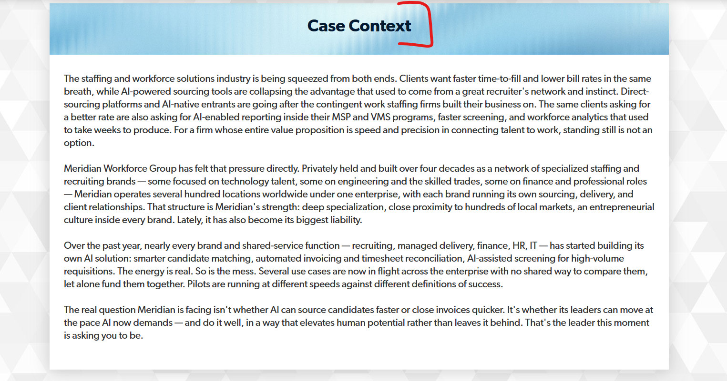

Shouldn’t we be swapping this icons?Done
The one with “Scenario” looks like a check list and with “Decision” is like a speech bubble. Done

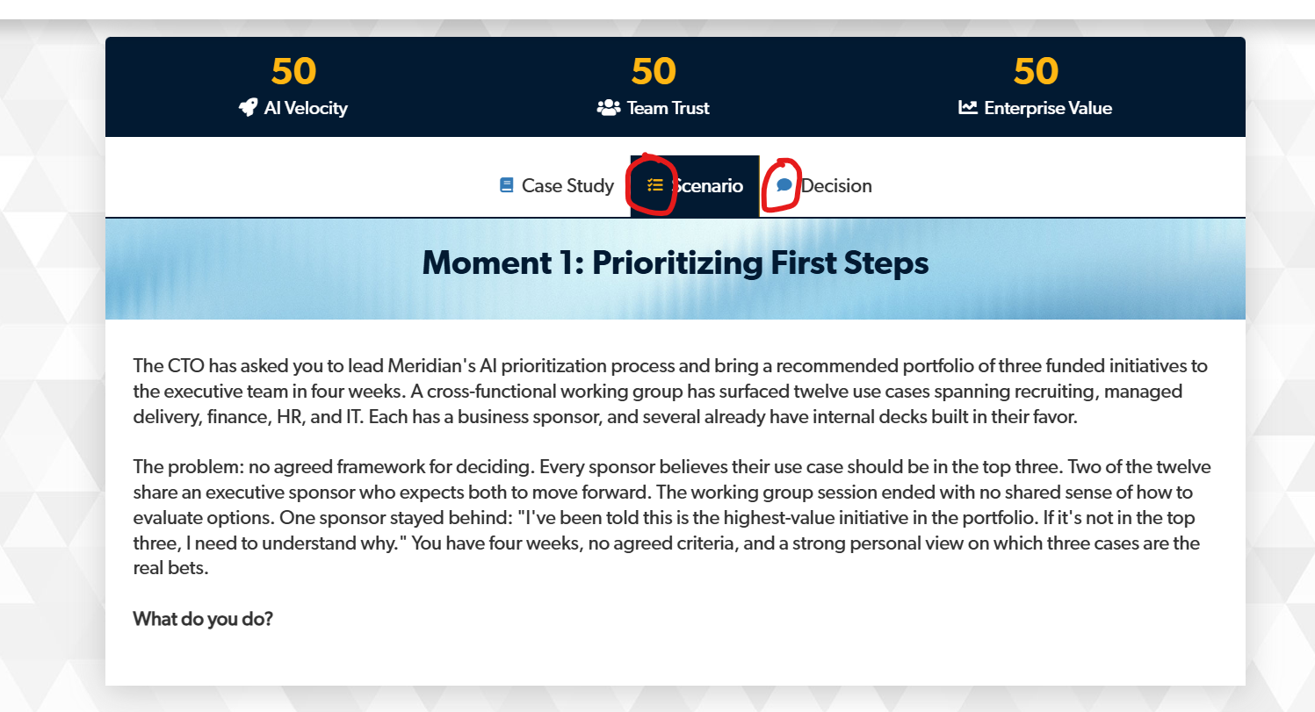

I have not chosen any option yet, and this text is visible already. Done
It becomes like a button only once I make a selection. Done

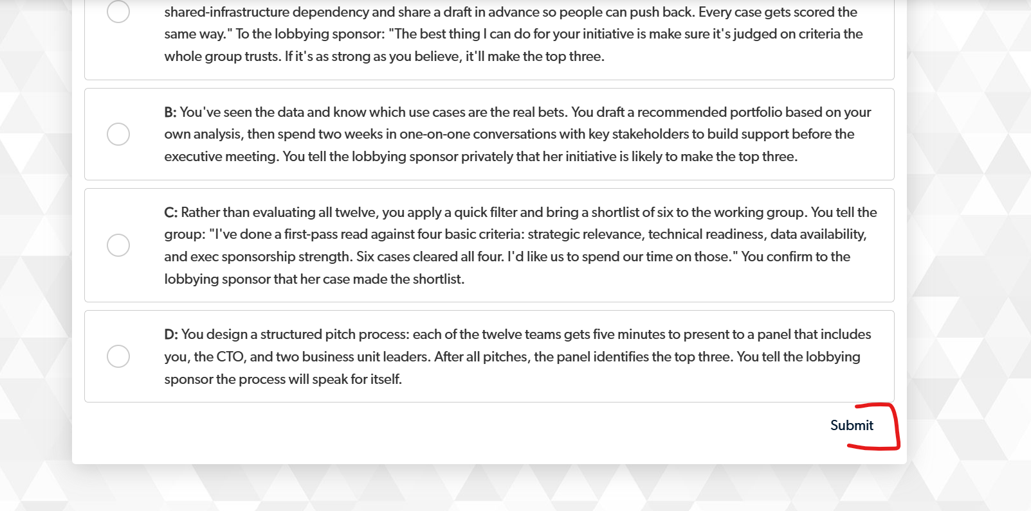

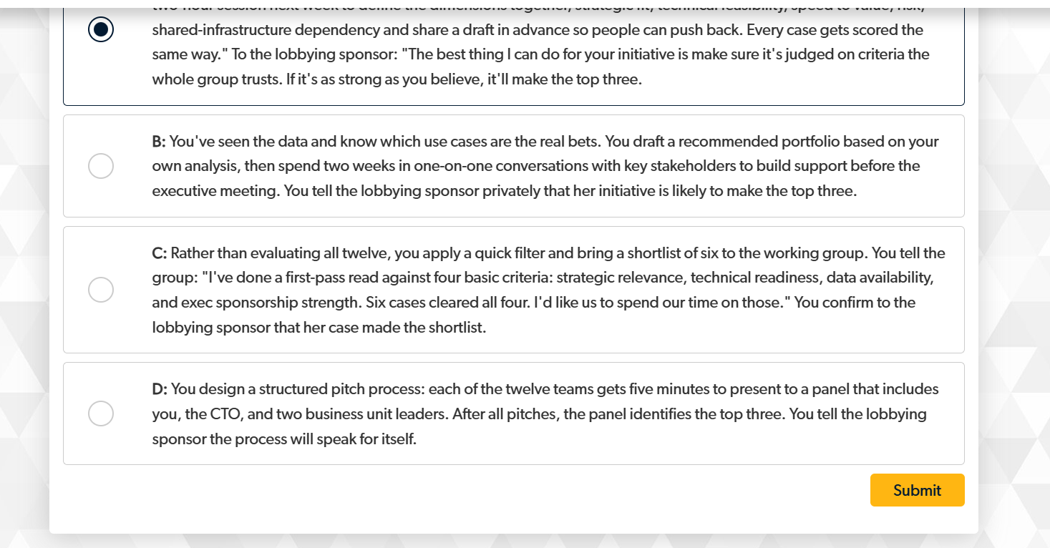

Can these numbers be centrally aligned wrt option text? They currently look top-aligned. Done

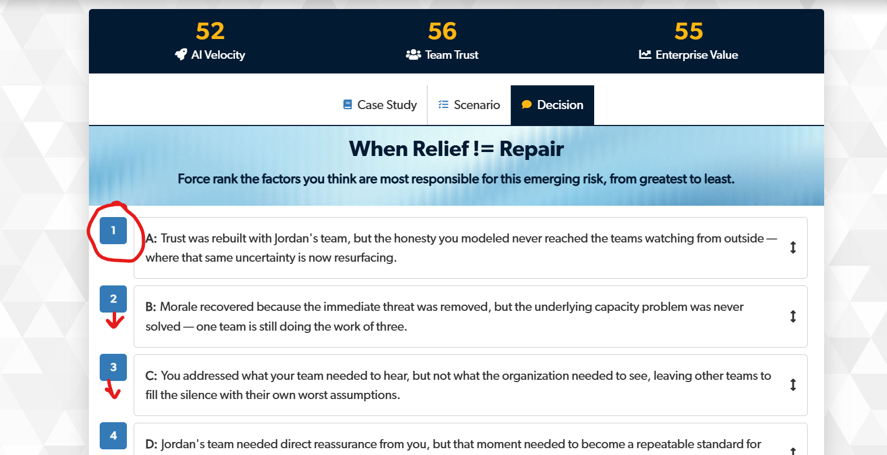

For F login, can we use a little lighter colours so that it looks disabled. Done

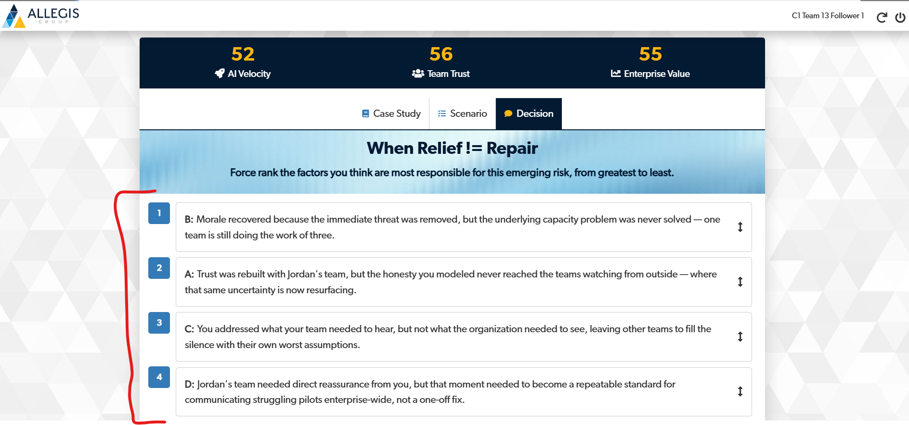

- Thanks for implementing this. It looks perfect to me!
- Can we update the right header to “Optimal Sequence” – sorry I should have mentioned this earlier! Done

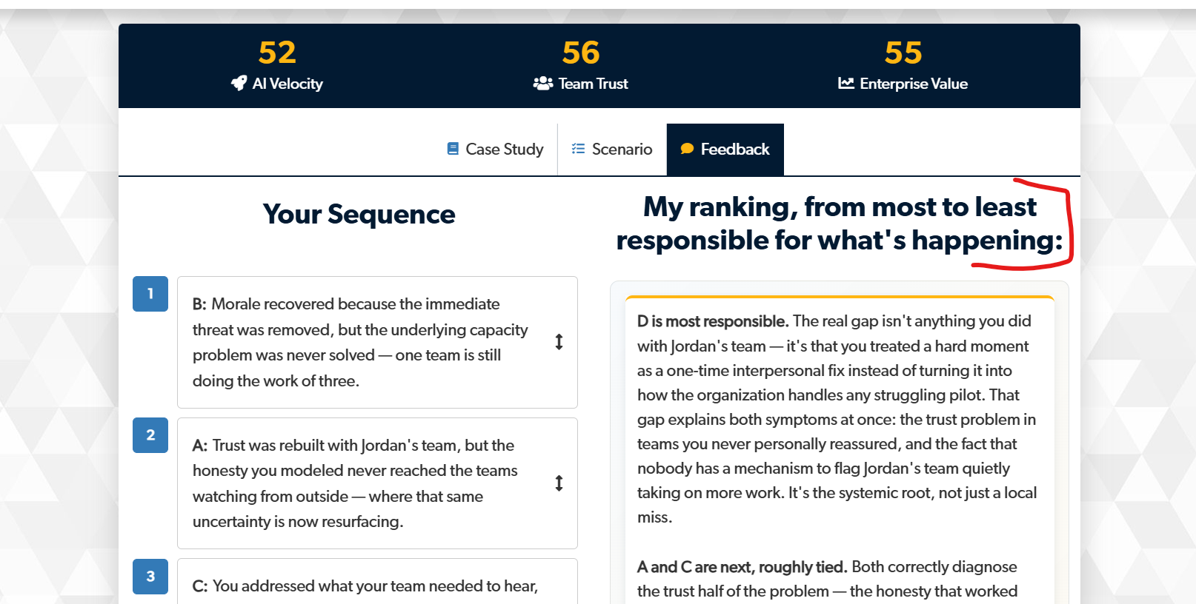

Too much of space – it can be reduced to half. Done
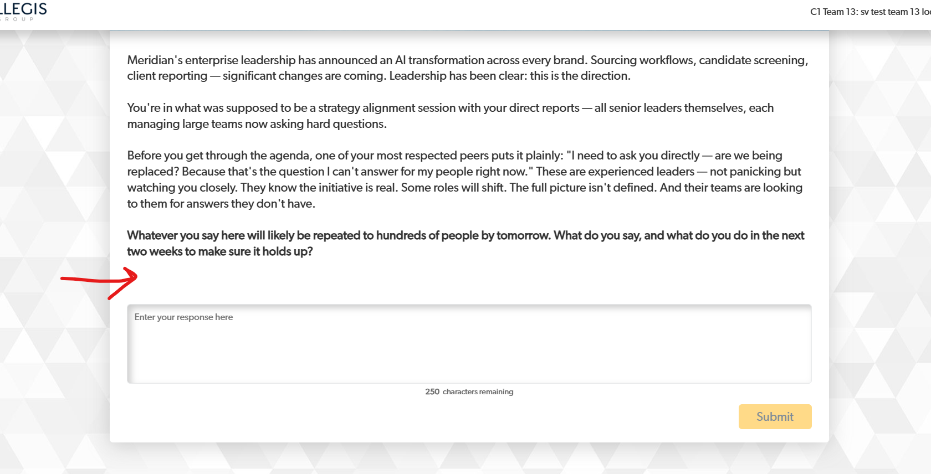

F screen is broken. Done
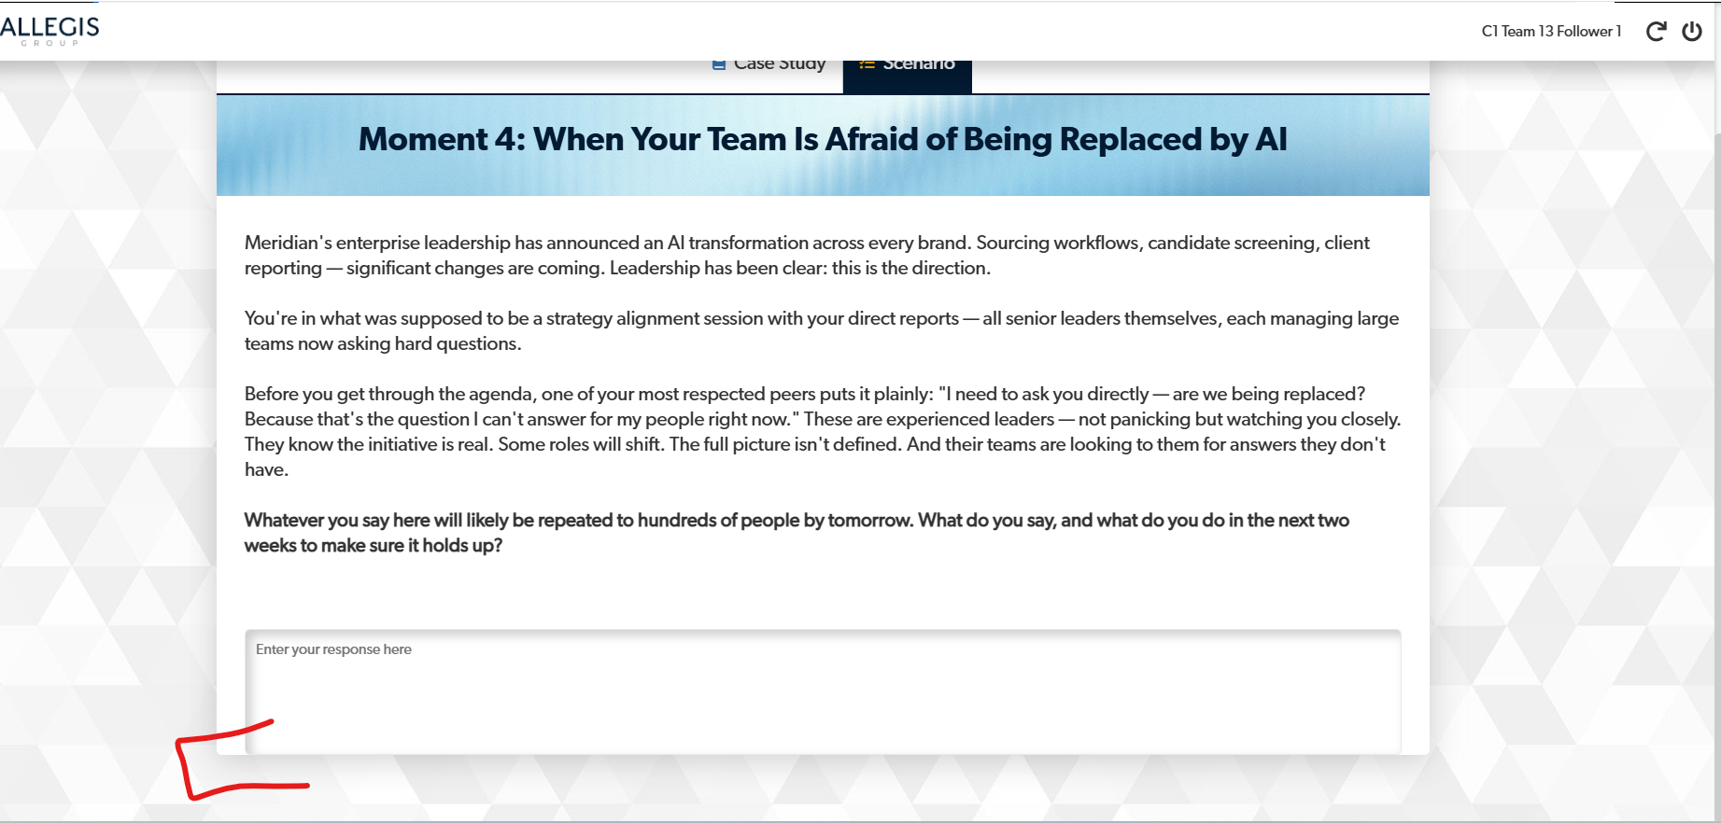

Make only the column header centrally aligned. Done

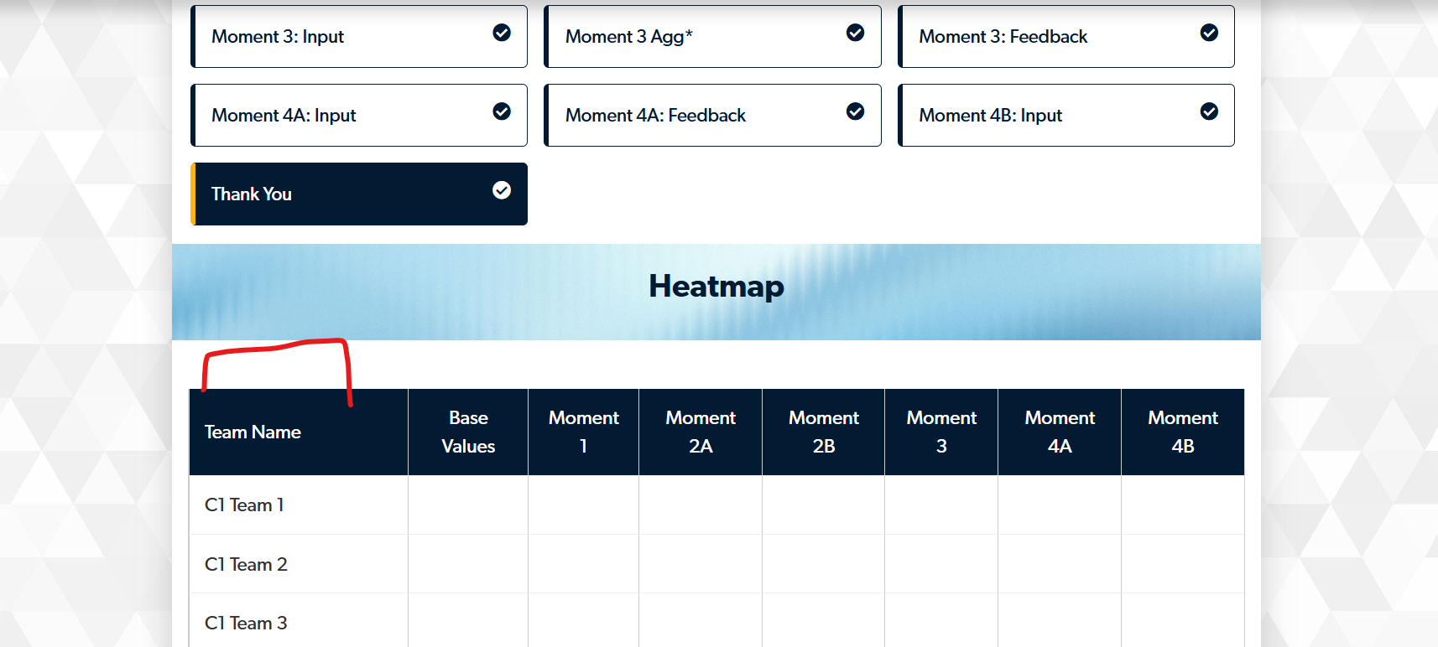

- Can this be moved above? Done
- Also, please increase the font size for Fac login. It looks fine on the laptop, but could be difficult to read from the big screen. Done
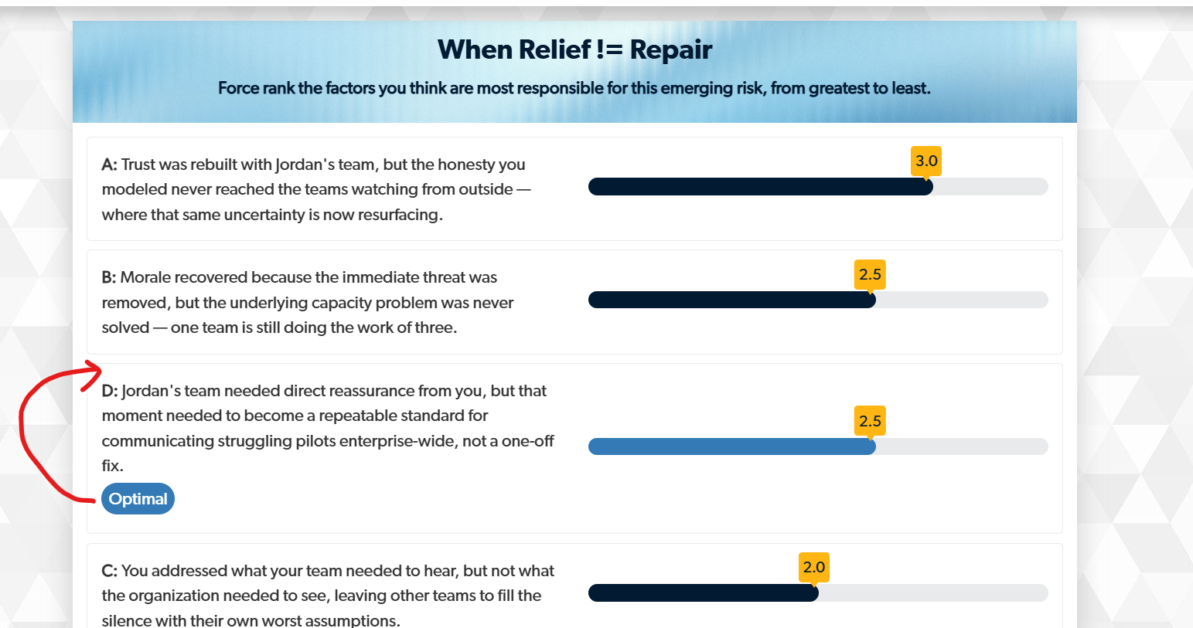

- These stars seem to be crashing into the border. Done
- Please add static leaderboard as well. Done

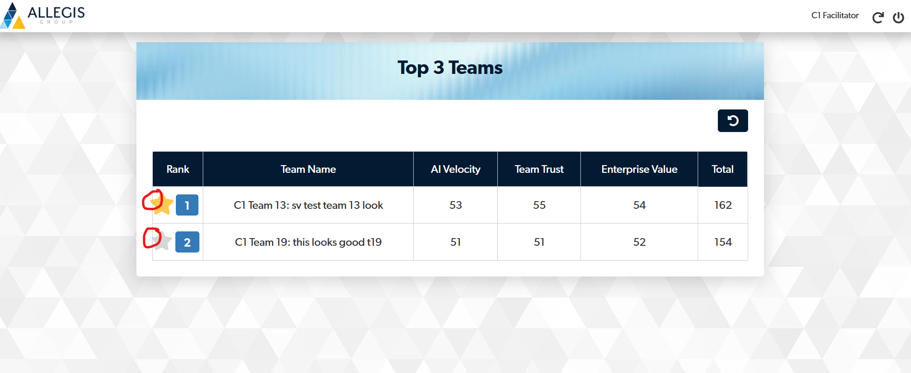

Please remove progressive leaderboard from reporter login. Instead add static leaderboard. Thanks Done

